Food Web App

Sequence Diagram

**Issued by:**

Nader Abdallah

**Reviewed by:**

1-Abdallah Ramdan

2-Menna Hesham

3-Mahmoud Eldghidy

Table of Contents

User Functionalities: 2

*SRS-US-01 (Sign up page)* 2

SRS-US-02 (Login Page) 3

SRS-US-06 (Restaurant Menu Page) 4

SRS-US-07 (Confirmation Page) 6

View Offers and Promotions sequences 7

Select an offer/Promotion to apply Sequence 8

SRS_US_10 9

(Loyalty Points -Nav Bar) 9

SRS-US-11 10

(My Account -Nav Bar) 10

Admin Functionalities: 11

Add new restaurant 11

SRS-A-01 11

Add menu item Sequence 11

SRS-A-02 11

Add Offers Sequence 12

SRS-A-05 12

## User Functionalities:

## SRS-US-01 (Sign up page)

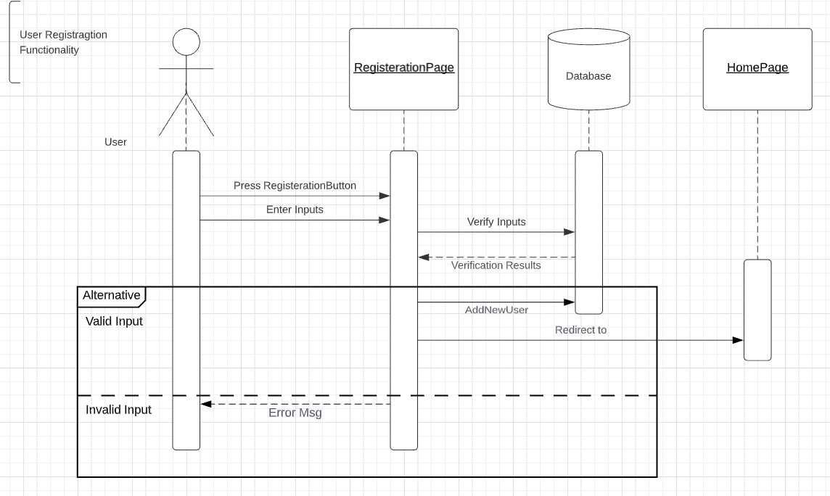

## SRS-US-02 (Login Page)

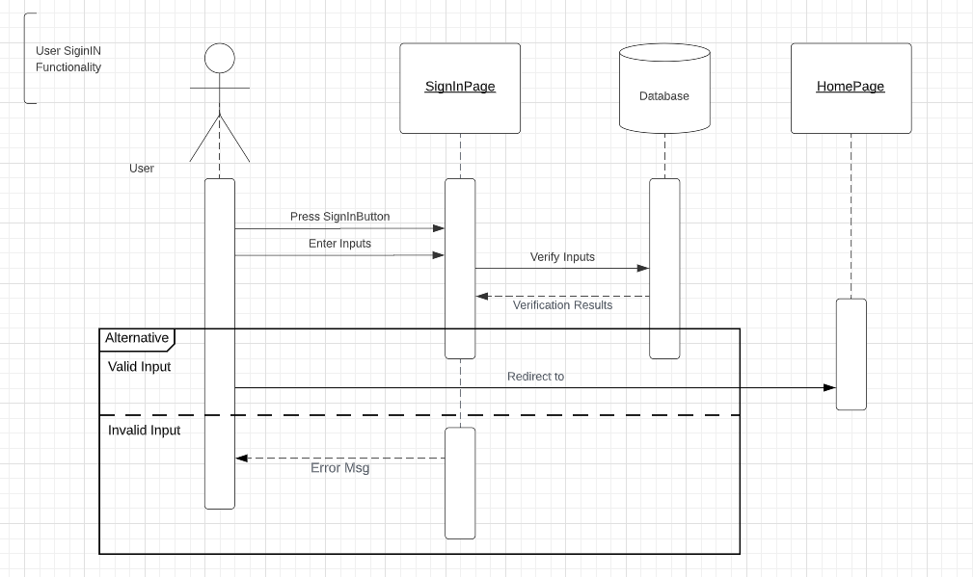

## SRS-US-06 (Restaurant Menu Page)

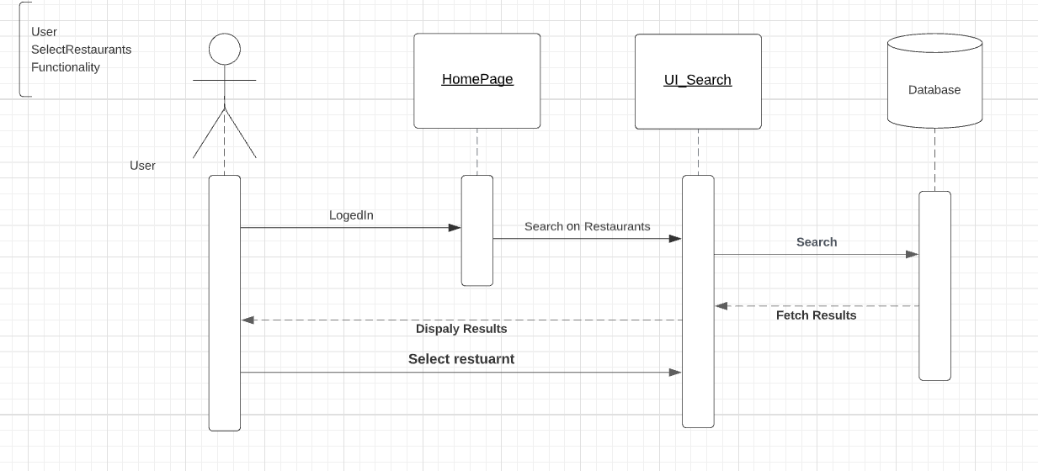

Select meals Sequence

ID: F_SQ_SelectMeal_005

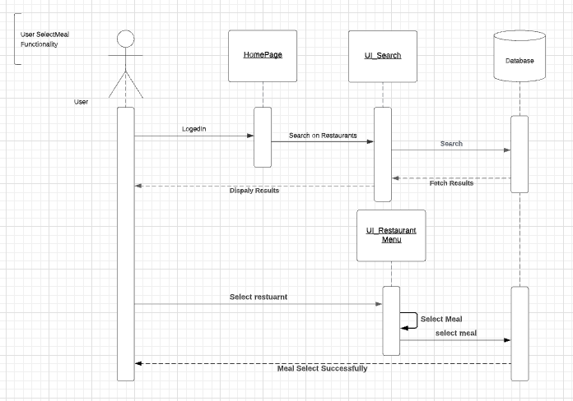

## SRS-US-07 (Confirmation Page)

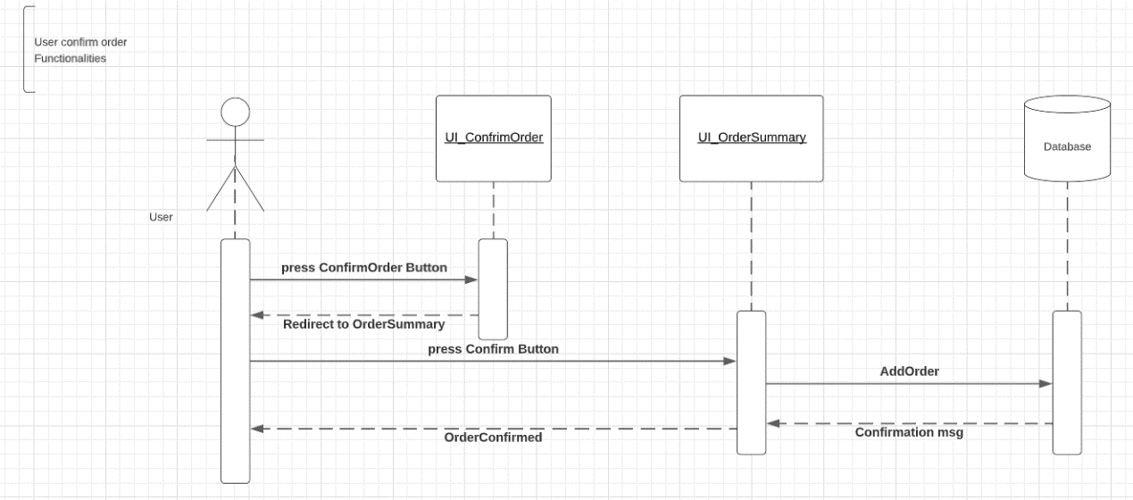

## View Offers and Promotions sequences

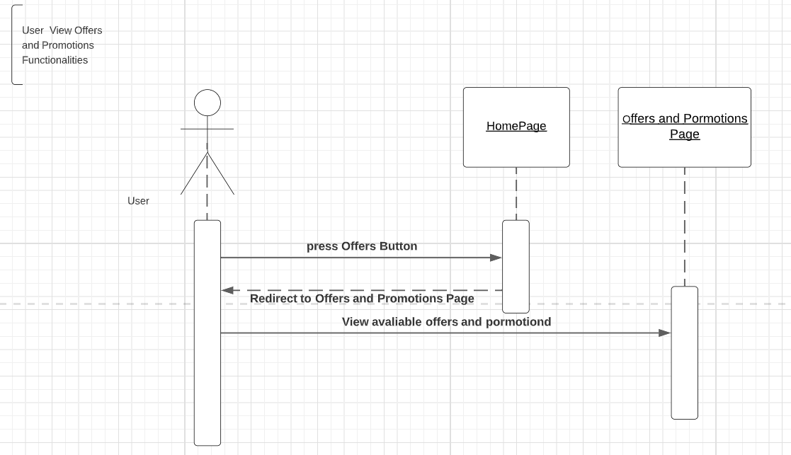

## Select an offer/Promotion to apply Sequence

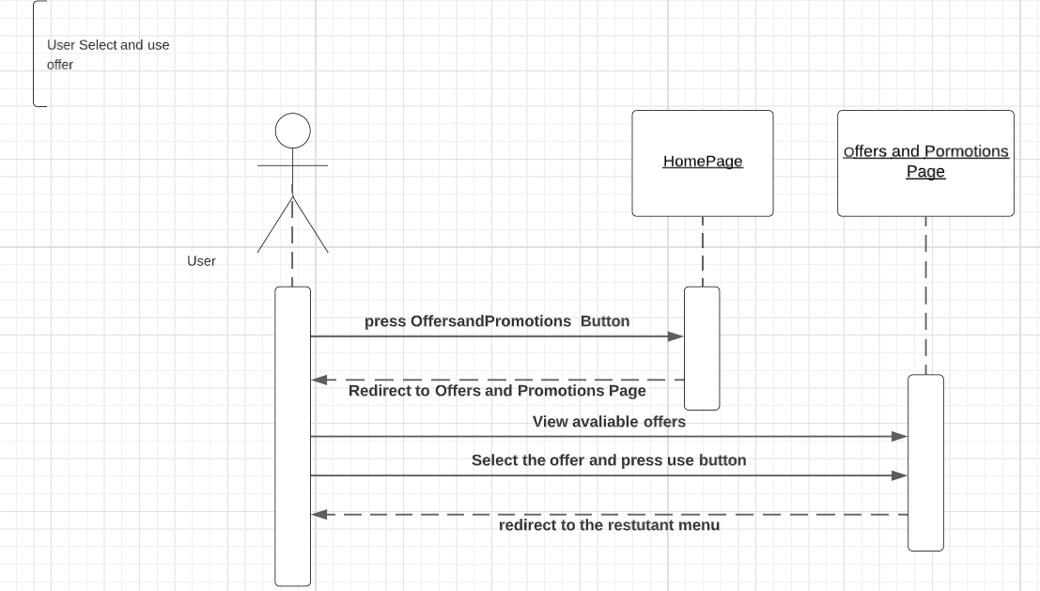

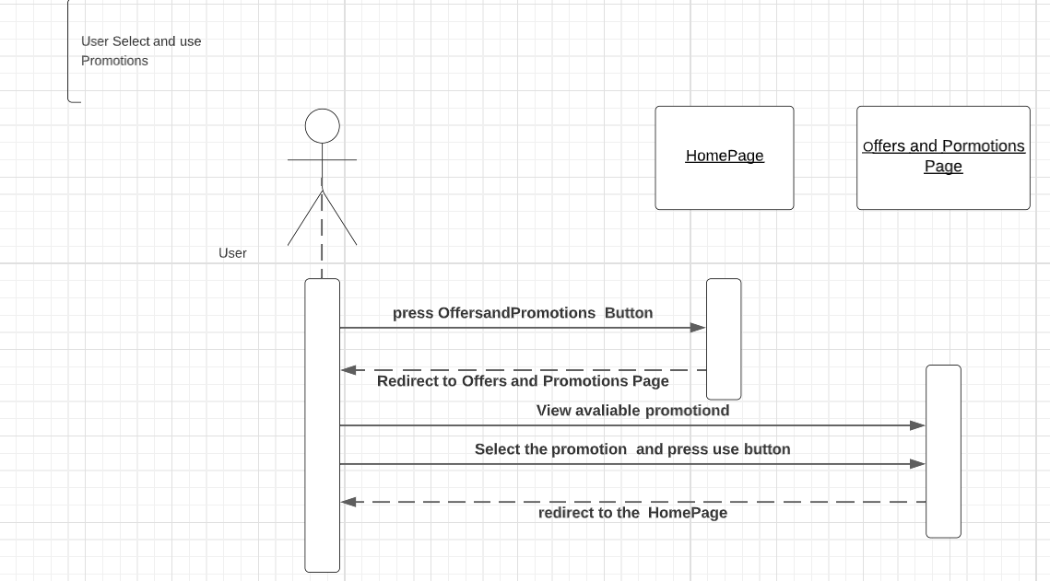

## SRS_US_10

## (Loyalty Points -Nav Bar)

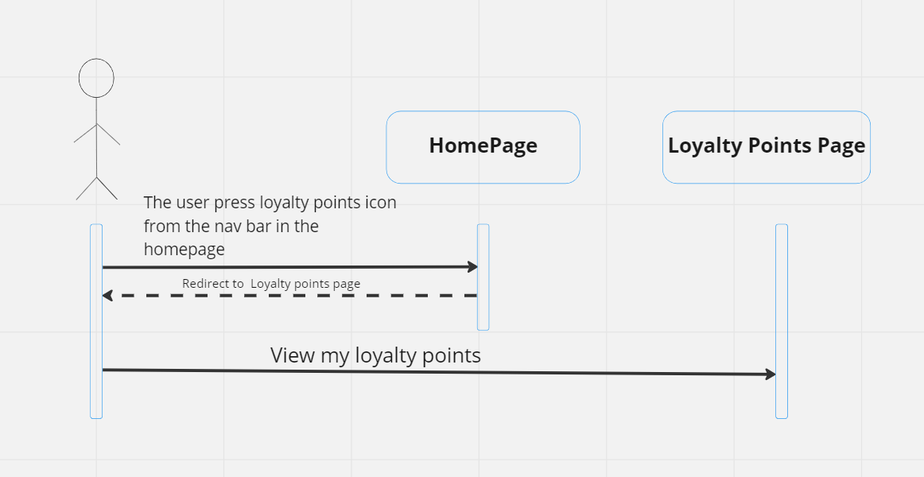

## SRS-US-11

## (My Account -Nav Bar)

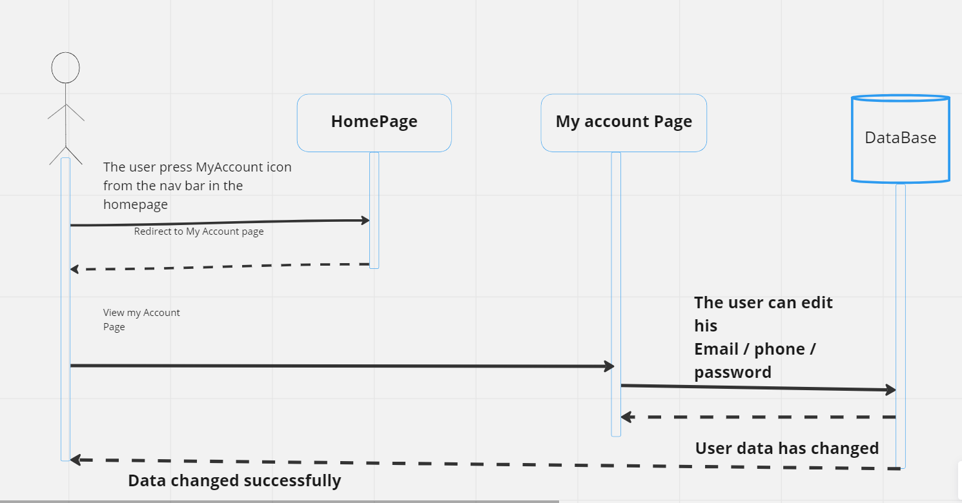

## Admin Functionalities:

## Add new restaurant

SRS-A-01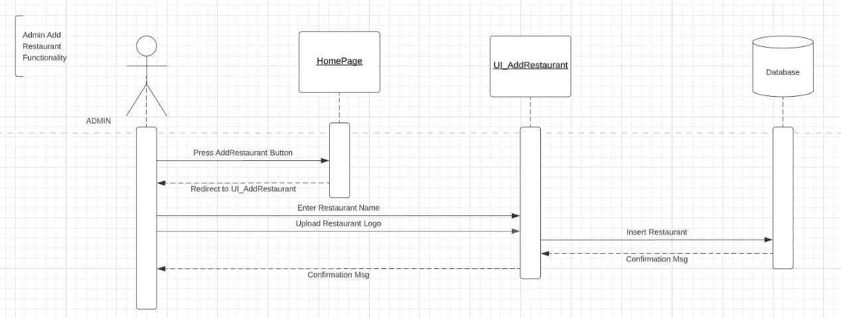

## Add menu item Sequence

## SRS-A-02

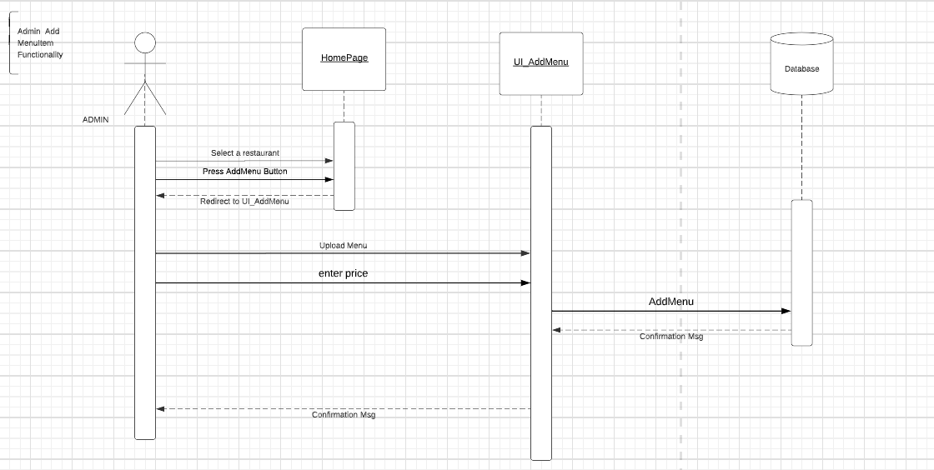

## Add Offers Sequence

## SRS-A-05

